

**Module 1 - Python Basics**

**Types:**

**Built-in Data Types in Python**

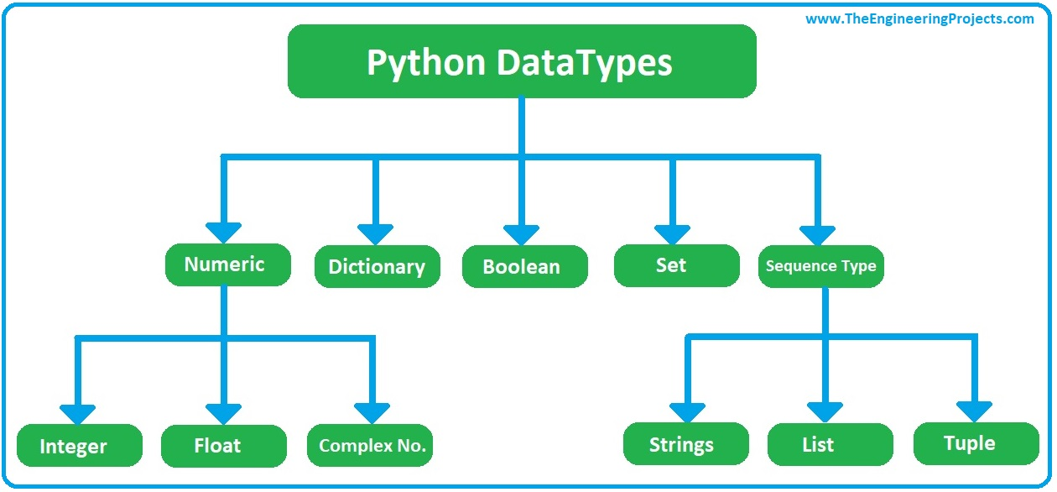

|  |  |
| --- | --- |
| Text Type: | str |
| Numeric Types: | int, float, complex |
| Sequence Types: | list, tuple, range |
| Mapping Type: | dict |
| Set Types: | set, frozenset |
| Boolean Type: | bool |
| Binary Types: | Bytes, bytearray, memoryview |

**Int :**

x = 5

print(type(x))

str:

x = "Hello World"

print(x)

float:

x = 20.5

print(x)

complex:

x = 1j

print(x)

List:

x = ["apple", "banana", "cherry"]

print(x)

tuple:

x = ("apple", "banana", "cherry")

print(x)

range:

x = range (6)

print(x)

dict:

x = {"name" : "John", "age" : 36}

print(x)

set:

x = {"apple", "banana", "cherry"}

print(x)

frozenset:

x = frozenset({"apple", "banana", "cherry"})

print(x)

bool:

x = True

print(x)

**x = b"Hello"**

**x = bytearray(5)**

**x = memoryview(bytes(5))**

**Datatype With Actual Type**

|  |  |  |
| --- | --- | --- |
| **Example** | **Data Type** |  |
| x = str("Hello World") | str |  |
| x = int(20) | int |  |
| x = float(20.5) | float |  |
| x = complex(1j) | complex |  |
| x = list(("apple", "banana", "cherry")) | list |  |
| x = tuple(("apple", "banana", "cherry")) | tuple |  |
| x = range(6) | range |  |
| x = dict(name="John", age=36) | dict |  |
| x = set(("apple", "banana", "cherry")) | set |  |
| x = frozenset(("apple", "banana", "cherry")) | frozenset |  |
| x = bool(5) | bool |  |
| x = bytes(5) | bytes |  |
| x = bytearray(5) | bytearray |  |
| x = memoryview(bytes(5)) | memoryview |  |

**#Variable**

**#Python has no command for declaring variable**

**#A variable is created the moment you first assign a value to it**

**#number =20 and age=20**

**#Note: Variable do not need to declared with any particular type**

**#Variable Example**

a=10

b=45.5

c=True

d="Hitesh"

e=45j

**#Type Function for the get the type for variable**

print(type(a))

print(type(b))

print(type(c))

print(type(d))

print(type(e))

**String Operations:**

**1)**

**txt=** **"Hello This is Python String Example"**

**print(txt)**

**2)**

**a="hello world"**

**print(a[1])**

**3)**

**b="hello wordl!"**

**print(b[2:5])**

**4)**

**b="hello wordl!"**

**print(len(b))**

**5)**

**strip() Remove Only Space From start and End String:**

**c=" hello world "**

**print(c)**

**print(c.strip())**

**6)**

**d="Hello World"**

**print(d.lower())**

**print(d.upper())**

**7)**

**d="Hello World"**

**print(d.replace("H","P"))**

**8)**

**e="this, Python"**

**print(e.split(","))**

**# Setting the maxsplit parameter to 1, will return a list with 2 elements!**

x = txt.split("#", 1)

print(x)

#['apple', 'banana#cherry#orange']

**#if pass 0 then it will show same String**

**['apple#banana#cherry#orange']**

**9)**

**#Concate Function**

**a1="This is Python "**

**a2="Demo"**

**c1=a1+a2**

**print(c1)**

**10)**

**Format Function:**

**age=28**

**str="My Name is Hitesh and i m {}"**

**print(str.format(age))**

**11)**

**FIRST CHARACTER CAPITALIZED IN WHOLE STRING**

**str1="hello students, welcome to python world"**

**x=str1.capitalize()**

**print(x)**

**12)**

**COUNT TOTAL NUMBER OF OCCURANCE WORDS IN STRING,IT RETURN INTEGER VALUE**

**str3="i love apple,apple is my favourite fruit"**

**x=str3.count("apple")**

**print(x)**

**ANS : 2**

**13)**

**IT RETURN POSTION WHERE WORD MATCH**

**ONLY FIRST MATCH WORD RETURN**

**IT RETURN INTEGER VALUE.**

**str5="Hello,Welcome to python."**

**x=str5.find("Welcome")**

**print(x)**

**ANS: 6**

**14)**

**CHECK IS ALPHA OR NUMBERIC THEN RETURN TRUE OTHERWISE RETRUN FALSE.**

**txt1="111AAA"**

**x=txt1.isalnum()**

**print(x)**

**15)**

**IT RETURN TRUE OR FALSE IT CHECK ONLY ALPHA THEN RETUREN TRUE OTHERWISE FALSE.**

**txt2="Hitesh"**

**x=txt2.isalpha()**

**print(x)**

**16)**

**IT RETURN TRUE WHEN MATCH ONLY DIGIT OTHERWISE FALSE.**

**txt4="1234500"**

**x=txt4.isdigit()**

**print(x)**

**17)**

**ALL WORD FIRST LETTER CAPITAL**

**txt5="welcome to python world"**

**x=txt5.title()**

**print(x)**

**18)**

**#end attribute use to join two statment**

print("hitesh kachhela",end="");

print(" python")

**19)**

**#use saperator sep=**

print("hi","hello","This is Python",sep="-")

**Ans : hi-hello-This is Python**

**20)**

**Format Function:**

**Answer is : 10+20=30**

**a=10**

**b=20**

**c=30**

**print ("Answer is :",f"{a}+{b}={c}")**

**21)**

**#rawstring 'r'and 'R' String format remove**

print(R"hello\bpython!")

**🡪**

**id=10**

**name="hitesh"**

**print("my id is {} and name is {}".format(id,name))**

**print(f"My id is{id} and name is{name}")**

**🡪**

**txt = "For only {price:.2f} dollars!"**

**print(txt.format(price = 49))**

**--For only 49.00 dollars!**

**#named indexes:**

**txt1 = "My name is {fname}, I'm {age}".format(fname = "John", age = 36)**

**#numbered indexes:**

**txt2 = "My name is {0}, I'm {1}".format("John",36)**

**#empty placeholders:**

**txt3 = "My name is {}, I'm {}".format("John",36)**